Name : K.Mounith
Reg No : 192425090
Course Code : ITA0515
Course : Computer Vision
Slot : B

Experiment 1: Read an Image and Convert it to Grayscale
Aim
To read an image using OpenCV and convert it into grayscale.

Algorithm
- Start the program.
- Import the OpenCV library.
- Read the input image from the specified file path using cv2.imread().
- Verify that the image has been loaded successfully.
- Convert the color image into a grayscale image using cv2.cvtColor() with the COLOR_BGR2GRAY conversion flag.
- Store the grayscale image in a separate variable.
- Display the original image in one window.
- Display the grayscale image in another window.
- Wait for the user to press any key.
- Close all display windows and terminate the program.
- .

Python Code
import cv2

img = cv2.imread(r"C:\Users\admin\Downloads\image.jfif")

if img is None:
print("Image not found") else:
gray = cv2.cvtColor(img, cv2.COLOR_BGR2GRAY)

cv2.imshow("Grayscale Image", gray)

cv2.imwrite("gray_image.jpg", gray)

cv2.waitKey(0) cv2.destroyAllWindows()

Input Image: Output Image:
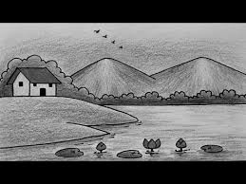

Result:
The input image was successfully read and converted into a grayscale image.

Experiment 2: Read an Image and Apply Gaussian Blur

Aim
To read an image using OpenCV and apply Gaussian Blur to reduce noise and smooth the image.

Algorithm
- Start the program.
- Import the OpenCV library.
- Read the input image from the specified file path.
- Verify that the image is loaded successfully.
- Choose a Gaussian kernel size (7 × 7).
- Apply the Gaussian Blur function using cv2.GaussianBlur().
- Store the blurred image.
- Display the original image.
- Display the blurred image.
- Wait for a key press and close all windows.

Python Code
import cv2

img = cv2.imread(r"C:\Users\admin\Downloads\image.jfif")

if img is None:
print("Image not found") else:
blur = cv2.GaussianBlur(img, (5,5), 0)

cv2.imshow("Blur Image", blur)

cv2.imwrite("blur_image.jpg", blur)

cv2.waitKey(0) cv2.destroyAllWindows()
Input Image: Output Image:

Result
Thus, the given image was successfully smoothed using the Gaussian Blur technique.

Experiment 3: Read an Image and Detect Edges using Canny
Aim
To detect the edges present in an image using the Canny edge detection algorithm.

Algorithm
- Start the program.
- Import the OpenCV library.
- Read the input image.
- Convert the image into grayscale.
- Specify the lower and upper threshold values.
- Apply the Canny edge detection function.
- Store the detected edge image.
- Display the original image.
- Display the edge-detected image.
- Wait for a key press and close all windows.

Python Code
import cv2

img = cv2.imread(r"C:\Users\admin\Downloads\image.jfif")

if img is None:
print("Image not found") else:
gray = cv2.cvtColor(img, cv2.COLOR_BGR2GRAY)

edges = cv2.Canny(gray, 100, 200)

cv2.imshow("Original Image", img)

cv2.imshow("Outline Image", edges)

cv2.imwrite("outline_image.jpg", edges)

cv2.waitKey(0) cv2.destroyAllWindows()

Input Image Output Image
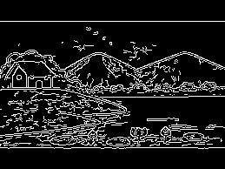

Result
Thus, the edges of the given image were successfully detected using the Canny edge detection algorithm.

Experiment 4: Perform Image Dilation
Aim
To perform the dilation operation on the given image using OpenCV.

Algorithm
- Start the program.
- Import the OpenCV and NumPy libraries.
- Read the input image from the specified path.
- Create a structuring element (kernel) of size 5 × 5.
- Apply the dilation operation using cv2.dilate().
- Increase the bright regions of the image.
- Store the processed image.
- Display the original image.
- Display the dilated image.
- Wait for a key press and close all windows.

Python Code
import cv2 import numpy as np

img = cv2.imread(r"C:\Users\admin\Downloads\image.jfif")

kernel = np.ones((5,5),np.uint8)

dilate = cv2.dilate(img,kernel,iterations=1)

cv2.imshow("Original",img) cv2.imshow("Dilated",dilate)

cv2.waitKey(0) cv2.destroyAllWindows() Input Image Output Image
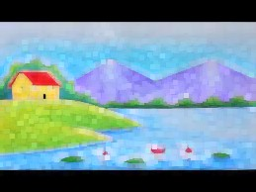

Result
Thus, the dilation operation was successfully performed on the given image.

